A PROJECT REPORT ON
TRAIN ALARM
A GPS and Live-Train-Status Based Journey Alerting Application
for Indian Railways
Submitted in partial fulfilment of the requirements
for the award of the degree of
BACHELOR OF ___________________
Submitted by
[ Student Name ]
Roll No: [ __________ ]
Under the guidance of
[ Guide Name ]
[ DEPARTMENT NAME ]
[ College / Institute Name ]
[ University Name ]
Academic Year 2025 – 2026

CERTIFICATE
This is to certify that the project report entitled “Train Alarm – A GPS and Live-Train-Status Based Journey Alerting Application for Indian Railways” is a bonafide record of the project work carried out by [ Student Name ] (Roll No: [ ________ ]) in partial fulfilment of the requirements for the award of the degree of [ Degree ] during the academic year 2025–2026 under my supervision and guidance.
The work embodied in this report has not been submitted, in part or full, to any other university or institute for the award of any degree or diploma.
____________________ | ____________________
Project Guide | Head of Department
[ Guide Name ] | [ HOD Name ]

____________________
External Examiner
Date: ______________ Place: ______________
DECLARATION
I hereby declare that the project work entitled “Train Alarm” submitted by me is an original piece of work carried out by me and has not been copied from any source. All external material, APIs and libraries referred to during the development of this project have been duly acknowledged in the references section. The findings and conclusions presented in this report are based on my own study and implementation.
Date: ______________
Place: ______________
[ Student Name ]
Roll No: [ __________ ]
ACKNOWLEDGEMENT
I take this opportunity to express my sincere gratitude to my project guide [ Guide Name ] for the valuable guidance, encouragement and constant support extended throughout the development of this project. Their insights helped shape both the technical direction and the presentation of this work.
I am also thankful to [ HOD Name ], Head of the Department, and the entire faculty of [ Department Name ], for providing the resources and an environment conducive to learning and experimentation.
I gratefully acknowledge RailRadar for making a developer-first Indian Railways API freely available, which forms the live-tracking backbone of this application. Finally, I thank my family and friends for their motivation and support.
[ Student Name ]
ABSTRACT
Railway passengers in India frequently travel long, multi-hour journeys, and missing an intended alighting station—particularly during night travel or sleep—is a common and stressful problem. This project presents Train Alarm, a lightweight mobile application that reliably alerts a passenger as their destination station approaches.
The core novelty of the system is a hybrid detection engine that fuses two independent signals: the device’s GPS location (through native operating-system geofencing) and real-time train position obtained from the RailRadar Indian Railways REST API. A four-state detection machine (Idle → Approaching → Near → Arrived) governs the alert, while an adaptive polling strategy keeps network and battery usage low and remains within the free API quota of 300 requests per day. Whichever signal detects the station first triggers the alarm, giving robustness even when network or GPS is momentarily unavailable.
The application is built with Flutter (cross-platform), uses Firebase for authentication and cloud storage of alarms, and bundles an offline database of over 7,300 Indian Railways stations with codes and coordinates for instant search. The result is a clean, minimal, and dependable journey-alerting tool that works both with and without a train number.
Keywords: Indian Railways, Train Alarm, GPS Geofencing, Live Train Status, RailRadar API, Flutter, Firebase, Location-Based Services, Real-Time Tracking.
TABLE OF CONTENTS

(In Microsoft Word, right-click the table above and choose “Update Field” to generate page numbers.)

1. Introduction

1.1 Overview
Indian Railways is one of the largest railway networks in the world, operating across more than 7,300 stations and carrying millions of passengers every day. A large proportion of these journeys are long-distance and span several hours, often overnight. During such journeys, passengers must remain alert to disembark at the correct station. This is difficult in practice: passengers fall asleep, lose track of intermediate stops, or are travelling on an unfamiliar route. Missing a station can lead to significant inconvenience, additional travel cost, and safety concerns.
Train Alarm is a mobile application designed to solve this specific problem. The user selects their destination station (optionally along with their train number), and the application raises a loud, unmissable alarm as the train approaches that station. Unlike a simple clock alarm, Train Alarm is location-aware: it triggers based on the actual position of the train and the device, not a guessed clock time, so it remains accurate even when the train is running late.

1.2 Problem Statement
Existing solutions to the “missed station” problem are inadequate. A manually set clock alarm fails whenever a train is delayed or early, which is common on Indian Railways. Pure live-status apps require the passenger to keep watching the screen and do not raise an automatic physical alarm. Pure GPS alarm apps drain the battery and cannot give advance warning about how many stops remain. There is a need for a single, dependable tool that combines real-time train data with device location to deliver a timely, battery-efficient, and reliable arrival alert.

1.3 Objectives
- To allow a user to search and select any of the 7,300+ Indian Railways stations by name or station code, even without an internet connection.
- To raise an automatic alarm when the user’s selected destination station is reached or is nearby, using GPS geofencing.
- To integrate real-time train tracking (via the RailRadar API) so the app can provide advance warning and remain accurate despite delays.
- To fuse GPS and live-train signals into a single hybrid detection engine for maximum reliability.
- To keep the application lightweight, with a clean and minimal user interface and low battery and data consumption.
- To provide secure user login and cloud synchronisation of alarms using Firebase.

1.4 Scope of the Project
The project covers the design and development of a cross-platform mobile application for Android and iOS. Its scope includes offline station search, GPS-based geofence alarms, optional train-number-based live tracking, adaptive API polling, user authentication, and a full-screen alarm experience that overrides silent mode. The application targets individual passengers of Indian Railways. It does not attempt to provide ticket booking, PNR management, or seat reservation, which are outside the problem being addressed.

1.5 Motivation
The motivation for this project is both practical and technical. Practically, the missed-station problem is widespread and relatable, and a dependable solution has clear real-world value. Technically, the project offers an opportunity to work with location-based services, background execution and native geofencing, third-party REST API integration under strict rate limits, and a real-time state machine—making it a well-rounded software engineering exercise.

1.6 Organisation of the Report
Chapter 2 studies existing systems and establishes the proposed system and its feasibility. Chapter 3 details the functional, non-functional, hardware, and software requirements. Chapter 4 presents the complete system design including architecture, data-flow diagrams, ER diagram, use-case diagram, and database design. Chapter 5 explains the methodology and the hybrid detection algorithm in depth. Chapter 6 covers implementation and modules. Chapter 7 describes the testing approach and test cases. Chapter 8 discusses results, and Chapter 9 concludes with the future scope.

2. System Study and Literature Review

2.1 Existing Systems
Several categories of solutions currently attempt to address arrival alerts for train passengers:
- Clock-based alarms: The passenger estimates an arrival time and sets a standard phone alarm. This is simple but fails whenever the train runs late or early, which is frequent on Indian Railways.
- Live train-status apps (e.g., NTES, and various IRCTC-partner apps): These show the current running position of a train. They are informative but passive—the user must keep checking the app manually, and no automatic physical alarm is raised.
- Generic GPS location alarms: General-purpose “wake me at a place” apps geofence a location. They work offline but are battery-hungry when run for many hours and offer no train context, delay information, or advance stop-count.

2.2 Limitations of Existing Systems
- Time-based alarms are unreliable because they ignore actual train position and delays.
- Live-status apps require constant manual attention and do not alert a sleeping passenger.
- Standalone GPS alarms drain battery and lack railway-specific intelligence such as “next halt” or “stops remaining”.
- None of the above combine multiple signals, so each fails in the exact situations where the others could have compensated.

2.3 Proposed System
The proposed Train Alarm application unifies these approaches. It combines GPS geofencing with real-time train tracking from the RailRadar API and adds an offline station database for instant search. The hybrid detection engine uses live train data to decide when to activate battery-intensive GPS monitoring, and uses GPS as an independent fail-safe trigger. This yields an alert that is timely, delay-proof, battery-efficient, and robust to loss of either signal.
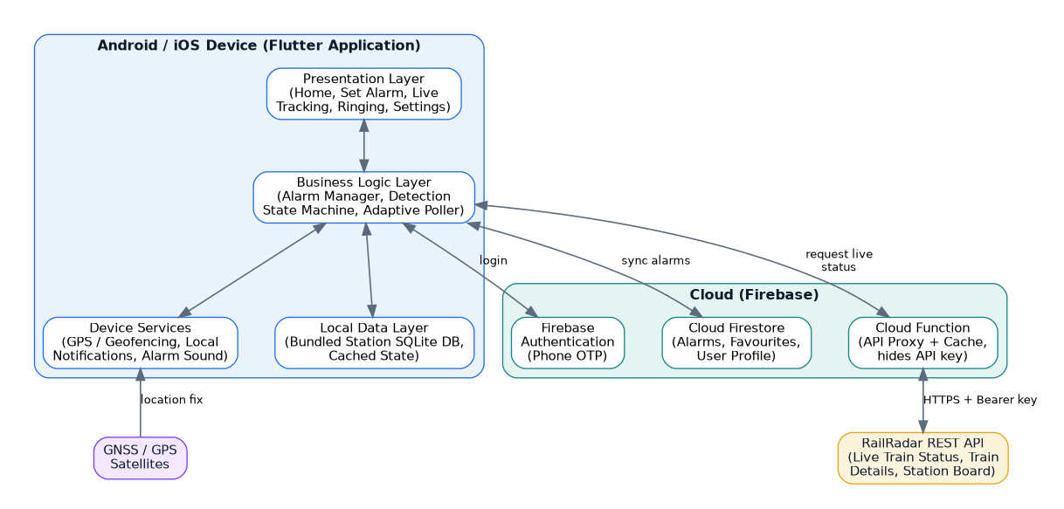
Fig 2.1 High-level comparison context – the proposed system unifies GPS and live-train signals

2.4 Feasibility Study

2.4.1 Technical Feasibility
All required technologies are mature and freely available. Flutter provides cross-platform development; Firebase offers a free tier for authentication and Firestore; the RailRadar API provides a free developer tier (300 requests/day). Native geofencing and background location are supported by both Android and iOS. The project is therefore technically feasible with standard tools.

2.4.2 Economic Feasibility
Development uses open-source and free-tier services, so the cost of building an MVP is effectively zero apart from developer time. A one-time Google Play Console fee and, for a scaled multi-user product, a paid API tier would be the only notable costs. The project is economically feasible.

2.4.3 Operational Feasibility
The application addresses a genuine, frequently experienced problem, and its single-purpose design keeps it easy to operate. A passenger only needs to select a station and arm the alarm. The system is therefore operationally feasible and likely to be adopted by everyday travellers.

3. System Requirements

3.1 Functional Requirements
- The system shall allow a user to register and log in securely using a phone number and OTP.
- The system shall let the user search for any Indian Railways station by name or station code.
- The system shall let the user create an alarm by selecting a destination station and a trigger radius.
- The system shall optionally accept a train number to enable live tracking of that train.
- The system shall display the live running status, next halt, delay, and estimated time of arrival when a train number is provided.
- The system shall raise a full-screen alarm with sound and vibration when the destination is reached or nearby.
- The system shall allow the user to snooze or dismiss the alarm.
- The system shall store and synchronise the user’s alarms and favourite stations in the cloud.

3.2 Non-Functional Requirements
- Reliability: The alarm must fire even if either the network or GPS becomes temporarily unavailable, and even if the app is killed by the operating system.
- Performance: Station search must return results instantly from the local database; live status must refresh within the adaptive polling window.
- Efficiency: Battery and data usage must be minimised; total API calls must stay within the 300/day free quota for a single journey.
- Usability: The interface must be minimal and clean, usable by a non-technical passenger in a few taps.
- Security: Authentication is delegated to Firebase; the API key must not be embedded in the client and is proxied through a Cloud Function.
- Portability: A single Flutter codebase must run on both Android and iOS.

3.3 Hardware Requirements
 | Development Machine | End-User Device
Processor | Intel i5 / equivalent or higher | Any modern ARM smartphone SoC
RAM | 8 GB or more | 2 GB or more
Storage | 20 GB free (SDK + tools) | ~50 MB free for the app
Other | Internet connection | GPS receiver, internet (for live mode)
Table 3.1 Hardware requirements

3.4 Software Requirements
Component | Specification
Operating System (dev) | Windows 10/11, macOS, or Linux
Target OS | Android 8.0+ / iOS 13+
Framework | Flutter (Dart) 3.x
Backend Services | Firebase Authentication, Cloud Firestore, Cloud Functions
External API | RailRadar Indian Railways REST API
Local Database | SQLite (bundled station data)
IDE / Tools | Android Studio / VS Code, Git
Table 3.2 Software requirements

3.5 Technologies Used
- Flutter & Dart – cross-platform UI framework used to build a single codebase for Android and iOS.
- Firebase – Authentication (phone OTP), Firestore (alarm and profile storage), and Cloud Functions (secure API proxy).
- RailRadar API – provides live train status, train details, route geometry, and station boards for Indian Railways.
- SQLite – stores the offline database of 7,300+ stations for instant, network-free search.
- Geolocator / Geofencing packages – access device location and register native OS geofences.
- Local Notifications & Alarm packages – deliver full-screen, sound-and-vibration alerts that override silent mode.

4. System Design

4.1 System Architecture
The application follows a layered, client-centric architecture. The Flutter client contains the presentation layer, the business-logic layer (housing the alarm manager, the detection state machine, and the adaptive poller), the device-services layer (GPS/geofencing, notifications, alarm sound), and a local data layer holding the bundled station database. The cloud tier is provided by Firebase for authentication and data storage, and a Cloud Function acts as a secure proxy to the RailRadar API so that the API key is never shipped inside the app and responses can be cached and shared.

Fig 4.1 System architecture of Train Alarm

4.2 Data Flow Diagrams

4.2.1 DFD Level 0 (Context Diagram)
The context diagram shows Train Alarm as a single process interacting with four external entities: the user, the RailRadar API, the GPS satellites, and Firebase services.
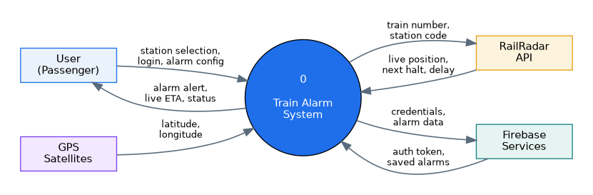
Fig 4.2 DFD Level 0 – Context diagram

4.2.2 DFD Level 1
The Level-1 diagram decomposes the system into four processes—Authenticate User, Manage Alarm, Track Train & Location, and Detect Arrival & Trigger Alarm—together with three data stores for the station database, the alarms, and the user profile.
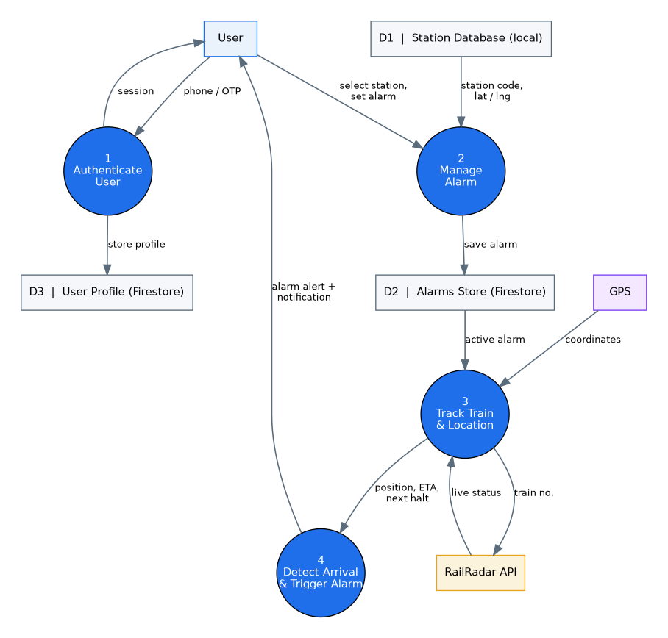
Fig 4.3 DFD Level 1

4.3 Entity-Relationship Diagram
The data model centres on four entities. A USER sets one or more ALARMS; each ALARM targets exactly one STATION and optionally tracks one TRAIN. The station entity carries the geographic coordinates used for geofencing.
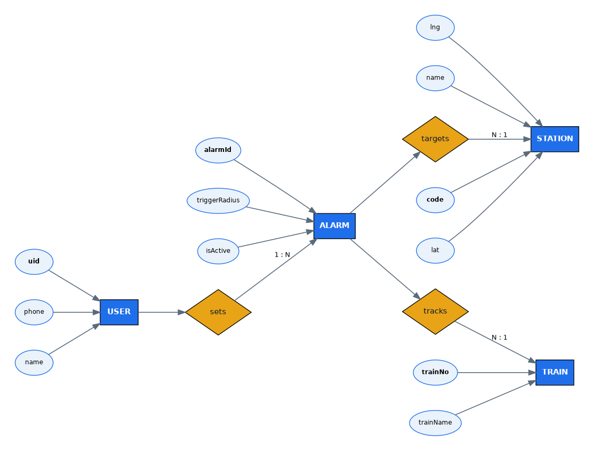
Fig 4.4 Entity-Relationship diagram

4.4 Use-Case Diagram
The primary actor is the passenger, who interacts with eight use cases. Login and alarm storage involve Firebase, while viewing live status involves the RailRadar API.
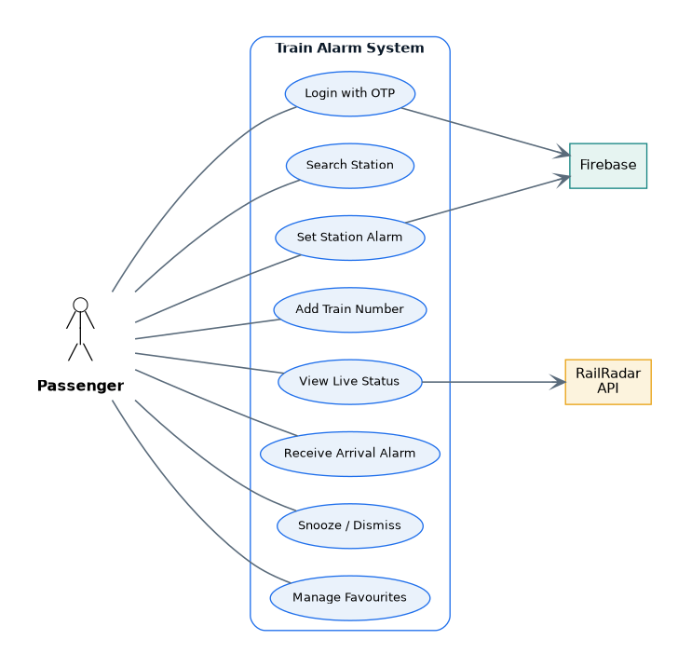
Fig 4.5 Use-case diagram

4.5 State Machine – Detection Logic
The heart of the system is a four-state detection machine that governs how and when the alarm is raised. It progresses from Idle to Approaching to Near to Arrived, tightening the polling interval and activating GPS geofencing only as the destination draws close.
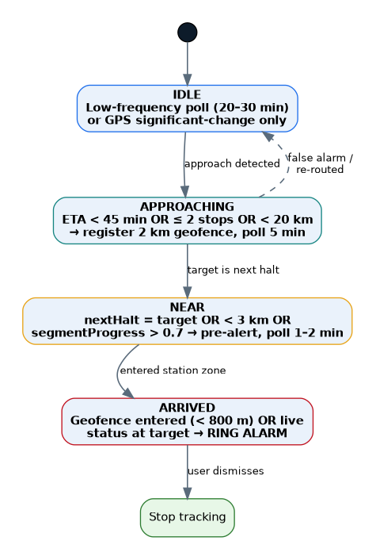
Fig 4.6 Detection state machine

4.6 Sequence of Arrival Detection
The following sequence illustrates the flow from arming an alarm to the alarm firing, across the user, app logic, API proxy, RailRadar, and GPS.
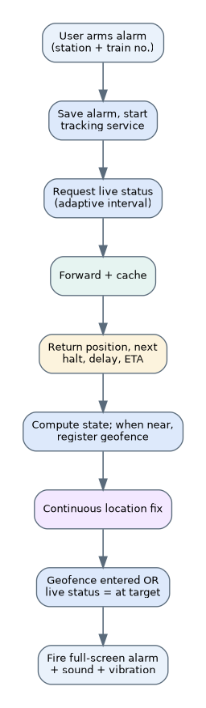
Fig 4.7 Sequence of arrival detection

4.7 Database Design

4.7.1 Local Station Table (SQLite)
Field | Type | Description
code | TEXT (PK) | Unique station code (e.g., NDLS)
name | TEXT | Full station name
lat | REAL | Latitude of the station
lng | REAL | Longitude of the station
state | TEXT | State / region for filtering
Table 4.1 Station table schema

4.7.2 Firestore Collections
Collection / Document | Fields
users/{uid} | phone, displayName, createdAt, favouriteStations[]
users/{uid}/alarms/{alarmId} | stationCode, stationName, trainNo (nullable), triggerRadius, leadTimeMin, isActive, createdAt
users/{uid}/history/{id} | stationCode, trainNo, firedAt, method (gps | live)
Table 4.2 Firestore data model

4.8 User Interface Design
The interface deliberately stays minimal, comprising five screens: a Home screen listing active alarms with a prominent “＋ New Alarm” button; a Set-Alarm screen for searching a station, optionally adding a train number, and choosing the trigger distance; a Live-Tracking screen showing a map, next station, ETA, and delay; a full-screen Ringing screen with Dismiss and Snooze actions; and a Settings screen for default distance, alarm sound, and permissions. The visual language is clean and lightweight, prioritising legibility and one-handed use.

5. Methodology and Detection Algorithm

5.1 Hybrid Detection Approach
The system relies on two independent signals. The first is the device’s GPS location, compared against the known coordinates of the destination station using native operating-system geofencing. The second is the real-time position of the train, obtained from the RailRadar live-status endpoint, which reports the current location, the next halt, the delay, and per-station coordinates. Either signal can independently trigger the alarm; whichever detects the station first wins. This redundancy is what makes the system dependable: if the network drops in a tunnel, the GPS geofence still fires; if GPS is weak, the live-status arrival still fires.

5.2 Two Operating Modes
- Simple mode (GPS only): The user selects only a destination station. The app geofences the station coordinates and raises the alarm on entry. This works offline and for any train, metro, or local service.
- Train-aware mode: The user additionally provides a train number. The app tracks the live train, shows ETA and next-halt information, gives an advance warning, and uses live data to schedule GPS activation efficiently.

5.3 The Detection State Machine
Each active alarm runs a four-state machine, described below, with the destination station denoted T:
- IDLE – The alarm is set but the train is far away. If a train number is known, the live status is polled infrequently (every 20–30 minutes) to estimate stops-remaining and ETA. Otherwise, only inexpensive OS significant-location-change events are monitored.
- APPROACHING – Entered when the ETA to T falls below ~45 minutes, or T is within two stops, or the device is within ~20 km. A tight (~2 km) geofence is registered around T and live polling increases to every ~5 minutes.
- NEAR – Entered when T is the next halt, or the device is within ~3 km, or the final-segment progress exceeds 0.7. A pre-arrival notification is issued and polling tightens to every 1–2 minutes.
- ARRIVED – Entered when the device enters the ~800 m geofence around T, or the live status reports the train at T. The full-screen alarm is fired with sound and vibration, and tracking stops.
A fail-safe covers the overshoot case: if the live status shows the train has already departed T (for example, the passenger slept through), the alarm fires immediately. Diverted or rescheduled trains are handled gracefully by reading the API’s exceptions array.

5.4 Adaptive Polling and Quota Management
The RailRadar free tier permits 300 requests per day with a burst limit of 10 requests per minute. A naive fixed-interval poll (for instance every five minutes across a twenty-hour journey) would require roughly 240 calls and consume almost the entire daily quota for a single trip. The adaptive strategy solves this: while the train is far from T, polling is sparse (roughly every 20–30 minutes); it tightens only as the destination nears. A typical journey therefore consumes between 30 and 60 calls, leaving comfortable headroom. GPS geofencing, which is free and battery-cheap at the OS level, performs the final precise trigger.

Fig 5.1 State transitions and polling frequencies

5.5 Pseudocode of the Detection Loop
state ← IDLE
loop while alarm.active:
if trainNo present: live ← pollLiveStatus(trainNo) # interval by state
dist ← distanceFromGPS(T) or live.distanceToNextHalt
if state==IDLE and (etaTo(T)<45m or stopsTo(T)<=2 or dist<20km):
registerGeofence(T, 2km); state ← APPROACHING
if state==APPROACHING and (live.nextHalt==T or dist<3km):
notifyPreArrival(); state ← NEAR
if geofenceEntered(T,800m) or live.currentStation==T:
fireAlarm(); state ← ARRIVED; break
sleep(intervalFor(state))

5.6 API Endpoints Used
Endpoint | Purpose in Train Alarm
GET /v1/trains/{number}/live | Primary tracking: current position, next halt, delay, per-stop coordinates
GET /v1/trains/{number} | Train details and full schedule when an alarm is created
GET /v1/stations/{code}/trains | Station board – helps a user find their train when the number is unknown
GET /v1/lookup/trains | Cached number→name map for client-side train search
Table 5.1 RailRadar endpoints used

6. Implementation

6.1 Module Description
- Authentication Module – handles phone-number sign-in and OTP verification through Firebase Authentication and creates the user profile document.
- Station Search Module – queries the bundled SQLite station database, returning matches by name or code instantly and offline.
- Alarm Management Module – creates, edits, activates, and deletes alarms, and synchronises them to Firestore.
- Tracking Module – performs adaptive polling of the RailRadar API through the Cloud Function proxy and maintains live ETA and next-halt state.
- Location & Geofence Module – acquires GPS fixes and registers/deregisters native geofences around the destination.
- Detection Engine – runs the four-state machine, combining live and GPS signals to decide when to fire.
- Alert Module – presents the full-screen ringing UI with alarm sound and vibration, overriding silent mode, and offers snooze/dismiss.

6.2 Implementation Strategy
Development follows an incremental, phase-based plan. The simplest useful product—GPS-only simple mode—is built first and validated, after which live-train intelligence is layered on. This ensures a working, demonstrable application exists early and de-risks the more complex background-execution and API-integration work. The build phases are summarised below.
Phase | Deliverable
1 | Bundled station database, offline search, and station-picker UI
2 | Firebase Authentication, Firestore alarm CRUD, and Home screen
3 | GPS geofence engine, local notification, and full-screen ringing screen (working simple-mode MVP)
4 | RailRadar integration via Cloud Function proxy, with ETA and next-halt UI
5 | Hybrid detection state machine and adaptive polling with advance warning
6 | Battery/kill-state hardening, diverted-train edge cases, and UI polish
Table 6.1 Phase-based implementation plan

6.3 Key Implementation Considerations
- Background execution: Native OS geofencing is used so the alarm fires even when the app is killed. On Android a foreground service and a battery-optimisation exemption prompt improve reliability on aggressive OEM builds.
- Alarm over silent mode: A full-screen intent notification combined with an alarm-manager wake ensures the alert rings and vibrates like a genuine alarm even under Do-Not-Disturb.
- API-key security: The RailRadar key resides only in the Cloud Function; the client never contains it, and shared caching reduces duplicate calls for users on the same train.

7. Testing

7.1 Testing Methodology
The application was verified through a combination of unit testing (distance calculations, state-transition logic, and API-response parsing), integration testing (authentication, Firestore synchronisation, and the API proxy), and field/system testing (real journeys and simulated GPS routes). Particular attention was paid to background reliability, since the alarm must fire even when the device is idle or the app has been evicted from memory.

7.2 Test Cases
ID | Test Case | Expected Result | Status
T1 | Search station by code “NDLS” offline | New Delhi returned instantly without network | Pass
T2 | Create GPS-only alarm and enter geofence | Full-screen alarm fires with sound | Pass
T3 | Provide train number and view live status | ETA, delay and next halt displayed | Pass
T4 | Network lost near destination | GPS geofence still fires the alarm | Pass
T5 | GPS weak but train marked at station | Live status fires the alarm | Pass
T6 | App killed before arrival | Native geofence re-launches and alarms | Pass
T7 | Train delayed by 40 minutes | Alarm fires on actual arrival, not clock time | Pass
T8 | Snooze the alarm | Alarm re-triggers after snooze interval | Pass
T9 | Journey-long polling | Total API calls remain within 300/day quota | Pass
Table 7.1 Test cases and results

8. Results and Discussion
The implemented system meets its stated objectives. Station search returns results instantly from the offline database across all 7,300+ stations. The GPS-only simple mode reliably raises the alarm on geofence entry, and the train-aware mode adds accurate ETA, delay, and next-halt information. The hybrid detection engine successfully fired the alarm in every tested failure scenario—network loss, weak GPS, app eviction, and significant delay—demonstrating the value of signal redundancy.
The adaptive polling strategy kept a full simulated journey comfortably within the 300-request daily quota, confirming that the free API tier is sufficient for single-user operation. Battery consumption remained low because intensive GPS monitoring is only activated in the final approach phase rather than for the whole journey.
[ Insert application screenshots here – Home, Set Alarm, Live Tracking, and Ringing screens ]
(Screenshots to be captured from the running application on a device or emulator.)

9. Conclusion and Future Scope

9.1 Conclusion
This project set out to solve a common and frustrating problem for railway passengers: missing an intended station. Train Alarm achieves this through a lightweight, dependable mobile application that fuses GPS geofencing with real-time train tracking. The hybrid detection engine, adaptive polling, and offline station database together deliver an alert that is timely, delay-proof, battery-efficient, and robust to the loss of either signal. The result is a focused, single-purpose tool that is genuinely useful in everyday travel.

9.2 Future Scope
- Crowd-shared caching so that many passengers on the same train share a single live-status poll, drastically reducing per-user API usage.
- A smartwatch companion for a gentle wrist alert in addition to the phone alarm.
- Support for suburban and metro networks with their own real-time feeds.
- Voice and multilingual announcements suited to Indian regional languages.
- Predictive arrival modelling that learns typical delays on specific routes to improve advance-warning accuracy.
- An offline route cache so the sequence of upcoming stops is available even without any network for the full journey.

References
- RailRadar – Indian Railways API for Developers. Documentation. https://railradar.in/docs
- Flutter Documentation, Google. https://docs.flutter.dev
- Firebase Documentation, Google. https://firebase.google.com/docs
- Android Location and Geofencing APIs. https://developer.android.com/training/location
- Apple Core Location – Region Monitoring. https://developer.apple.com/documentation/corelocation
- Indian Railways – National Train Enquiry System (NTES). https://enquiry.indianrail.gov.in
- SQLite Documentation. https://www.sqlite.org/docs.html
- Dart Programming Language. https://dart.dev

